**SSCBS**

**MAYANK CHOPRA**

**ROLLNO -23719**

**INFORMATION GATHERING**

**SHODAN SEARCH ENGINE – this is the search engine that lets user search for various types of servers connected to the internet using variety of filters. Some have also described it as a search engine of services, banners.**

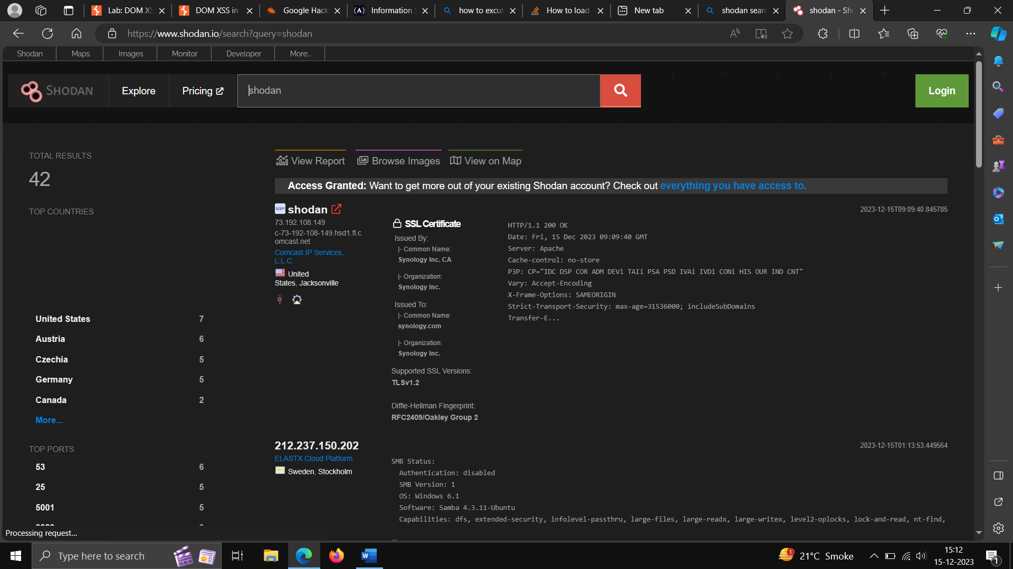

**WAY BACK MACHINE –**

**It allows the user to go back in time to see how website is looked in the past**

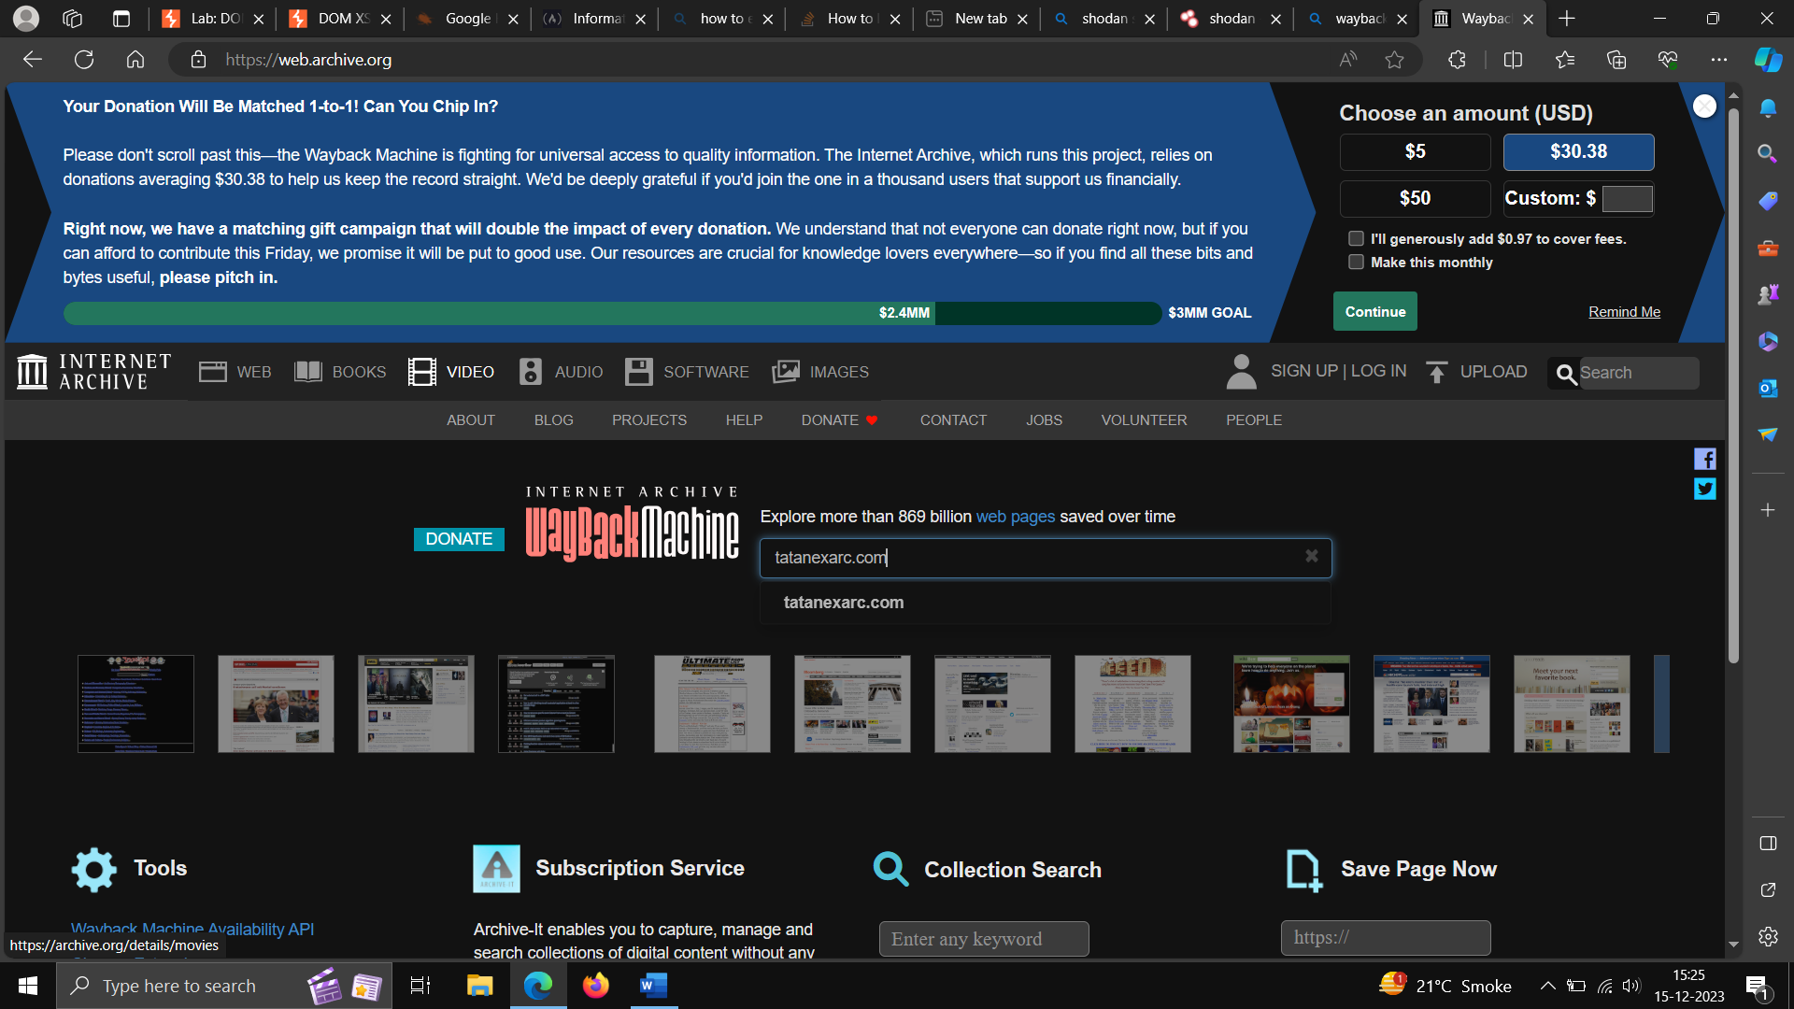

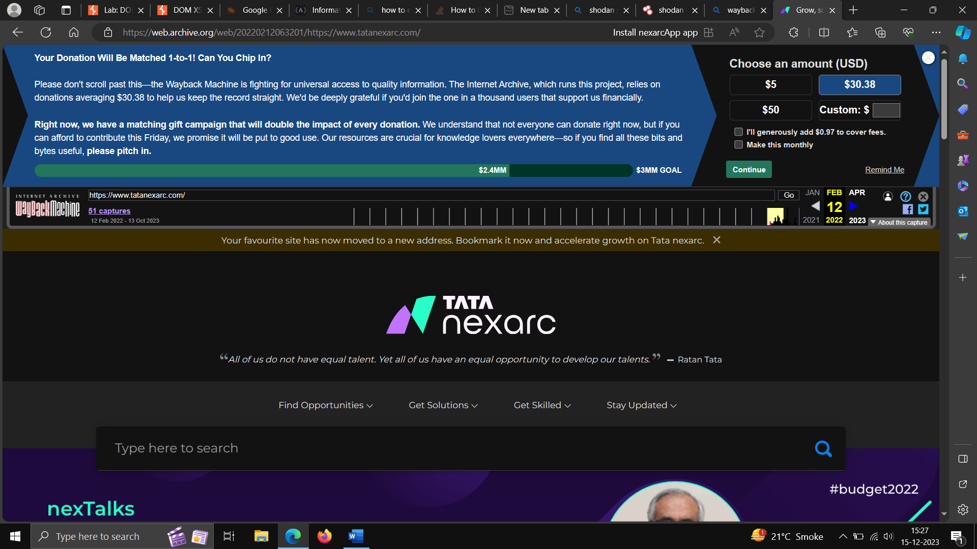

**WHOIS RECORD -WHOIS is a query and response protocol that is used for querying the databases that stores internal resources’ registered users.**

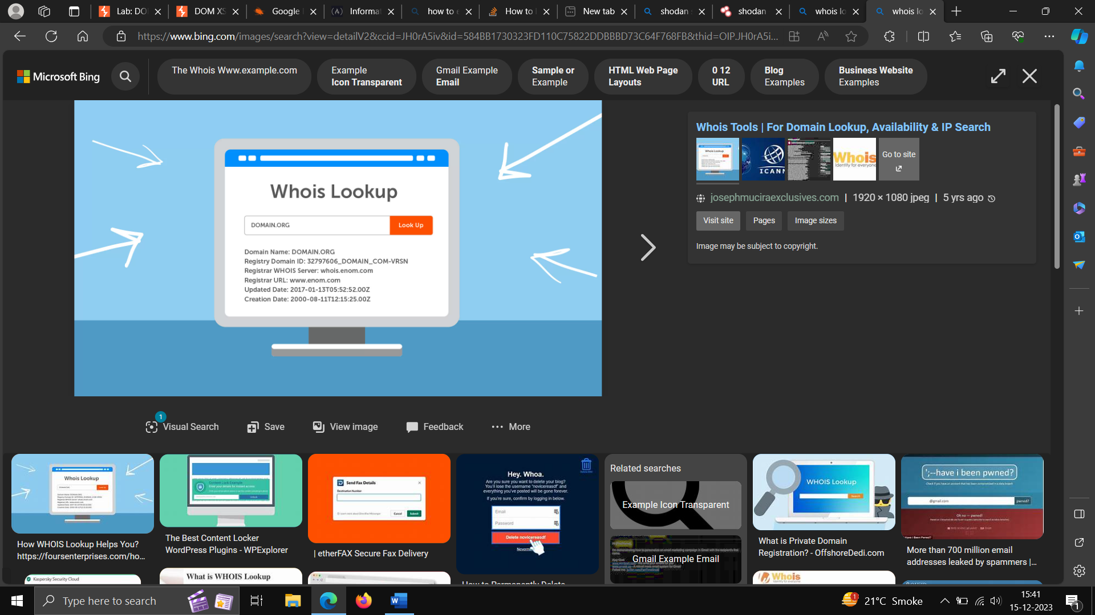

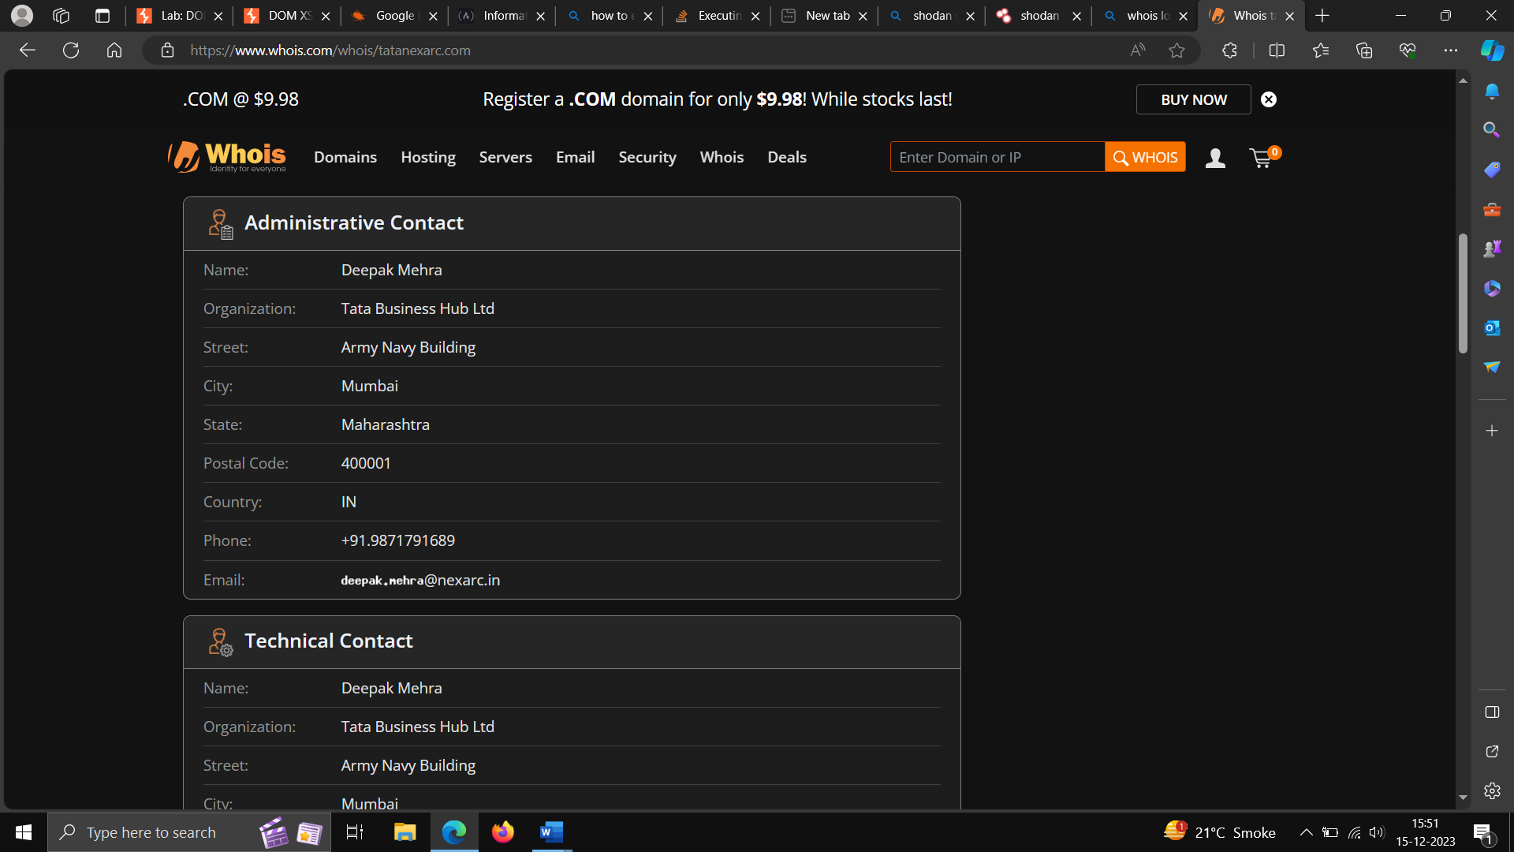

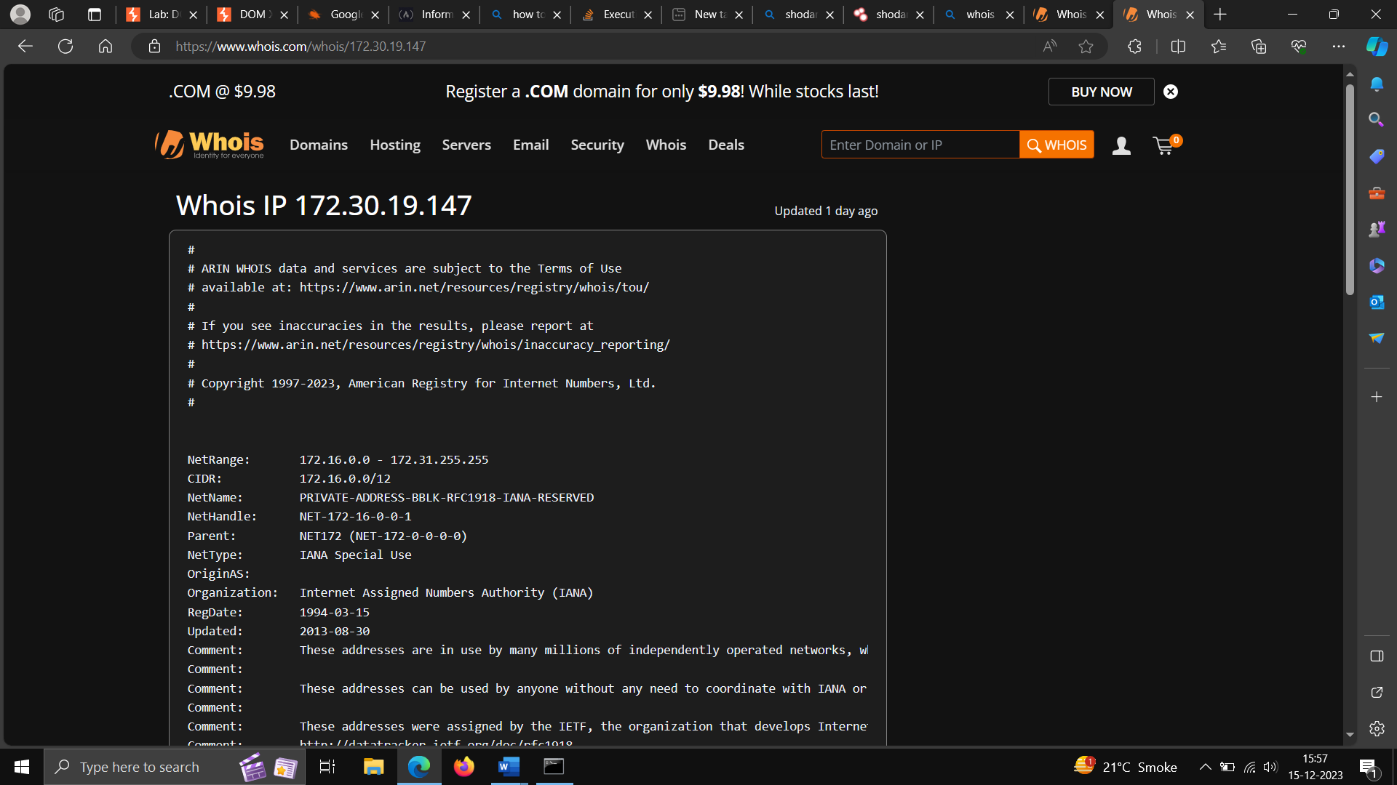

**TRACERT – the windows tracert tool determine the root to a destination by sending ICMP packets to the destination.**

**Use Tracert using tracert Ip address/domain name.**

